Professional Smart Card

Final Year Project Proposal

Session 2017-2021

A 4th Year Student

A project submitted in partial fulfilment of the

COMSATS University Degree

Of

BSc. (Hons.)BS in Computer Science (CUI)



Department of Computer Science

COMSATS University Islamabad, Attock Campus

13 April 2021

**Project Registration Form**

|  |  |  |  |  |  |  |  |  |
| --- | --- | --- | --- | --- | --- | --- | --- | --- |
| Project ID (for office use) | |  | | | | | | |
| Project Title | | Professional Smart Card | | | | | | |
| Type (Nature of project) | | [ ]Desktop Application [ ] Web Application [✓] Mobile Application | | | | | | |
| Area of specialization | | Android Application Development | | | | | | |
| **Project Group Members** | | | | | | | | |
| Sr.# | Registration No | | Student Name | CGPA | Email ID | | Contact No | Signature |
| 1. | CIIT/SP18-BCS-001/ATK | | SYED NATIQ HUSSAIN SHAH | 3.55 | syednatiqhusssain@gmail.com | | 0334-5235953 |  |
| 2. | CIIT/SP18-BCS-015/ATK | | YASIR IQBAL | 2.74 | y251229@gmail.com | | 0304-2351734 |  |
| 3. |  | |  |  |  | |  |  |
| Name & Signature of Program Coordinator to certify that  Are the students eligible for FYP? [ ] Yes [ ] No | | | | | |  | | |

# Consent and Plagiarism Certificate from Supervisor

I affirm to accept and supervise the above-mentioned students throughout the project duration. This is to certify that this FYP proposal is checked by mean and the similarity index is ________% that is less than 19%, an acceptable limit by HEC. Report is attached herewith.

Name of Supervisor: **M. Jamal Ahmed** Co-Supervisor (if any): _____________________

Designation: **Lecturer** Designation: ______________________

Signature:_____________ Signature: ____________________

**Approval of FYP Management Committee**

Committee Member 1: Name: _____________________

[ ] Accept [ ] *Defer [ ] *Reject Signature: _______________

*Remarks: _____________________________________________________________________

Committee Member 2: Name: _____________________

[ ] Accept [ ] *Defer [ ] *Reject Signature: _______________

*Remarks: _____________________________________________________________________

Convener: Name: _____________________

[ ] Accept [ ] *Defer [ ] *Reject Signature: _______________

*Remarks: _____________________________________________________________________

**Project Abstract:**

Professional Smart card is an android application, being a growing nation, it is needed to digitize the services of professional card. When somebody attends a workshop or seminar, he receives many cards that he will put into his pocket. After that he will take the pictures of cards instead of keeping them all the cards at all time in their pockets. Whenever the user wants to contact some person, he will thoroughly search either the images of all cards in his mobile gallery or in his pocket, that will not only waste the user time but also it will be a headache to search for a number through this process. This android application will not only reduce this effort but also provide a mechanism where user can scan the card and will save the phone number in the contact list. This application will also provide if the card has QR code then using the QR code, one can get the more detail of the card holder like restaurant details, doctor visits, businessmen etc. In this app the card holder professionals as well as normal users both will be treated. The application algorithm powered by AI learning algorithm will increase the accuracy as it scans the cards. Furthermore, we can design our smart card; make it virtual and Using AI algorithm we can share to a particular vicinity area so that other users can see the new products etc.

**Introduction:**

Most of the android users feel uncomfortable for keeping so much physical cards in their wallets. The android users are from the modern generation. They want to deal every problem in smart way. So here is the solution if someone wants to store the card to get service later. The user cantake the picture, save into phone gallery and throw card into dustbin. Using this application, we can save that phone number directly that is printed on the cardin the phonebook. In this application, if organization changeslocation, theydon’t have to update their cards by wasting the previous ones. They should not inform their old users about new location. They only have to change the location online in application and the notification will be sent to the users. Like a WhatsApp or other social media group, user can solve any problem by taking help from the community using the community chat service in the application. The world is digitalizing and everything is shifting online so as the business but the communication and marketing strategy is same sharing paper cards for the exchange of contacts so why not to change this trend also and develop a way to digitalized this thing by using digital cards which are easy to manage and handle and save time also. It also prevents the headache of carrying paper card bundles.Whenever the contact gets changed or updated it will also update it in the smartcard data. User can also find social media profiles of the card using QR code and given information. Physical cards are difficult to design and make copies and share with customers using different agents, in this way many resources are used. But in this application, Businessman can also upload their business card and can easily share with customer in very easy and cost saving steps. Based on location, this application will provide suggestions of the available businesses near customer location.

**Motivation and Scope:**

Printing the layout on the thick paper of the card is increasing the risk of ending the life of millions of trees annually. This adds the harmful effects on the environment especially in urban areas. Further, a recent research study shows that 88% of the customers throw their cards in the garbage within a week after receiving. The customer receives the card and forgets about that within days so the advertisement information will not fulfill its purpose. The amount of customer decreases and the businesses will start moving downwards. After analyzing these facts, we started thinking about this project. Why not convert the physical business card services into modern digital cards using the mobile application. Both team members are strongly concerned about this project. We found each other and started reading more articles and some research papers. As the time progressed our faith becomes stronger that it is the basic need to digitize the card service.Another thing is that if we are moving from one city to another city, we found many problems like changing the address and then distributing to the city is not easy but using this we can easily update and share it in near vicinity.

**Related Work:**

# Wantedly People scan biz cards: This is an android application in which physical cards can be scanned into phone and the contacts on it can be saved. The instant messages can be scan with the contacts.

1. **Haystack cards:**This is another android application having some relatable features in which digital business cards can be created in seconds. The cards can be shared through email and social media. Paper business card can be scanned into this application. This application auto updates the information in other devices as well.
2. **Switchit**:Switchit is a fun, innovative platform where you can create and share "Contactless"Digital Business Cards person-to-person or online. Create immersive, video-enabled digital business cards that visually connect people to your brand.

**Comparison Table:**

**Table 1**

|  |  |  |  |  |
| --- | --- | --- | --- | --- |
| **Functionality** | **Professional Smart Card (Proposed)** | **Haystack** | **Wantedly** | **Switchit** |
| **Scan Cards**  **(Using**  **QR-Code & OCR)** | **✔** | **✔** | **✔** | **✔** |
| **Social Circle** | **✔** | **✖** | **✖** | **✖** |
| **Nearby Business Suggestion** | **✔** | **✖** | **✔** | **✔** |
| **QR Code Scan** | **✔** | **✖** | **✖** | **✔** |
| **Update Contacts** | **✔** | **✔** | **✖** | **✖** |
| **Community Chat** | **✔** | **✖** | **✖** | **✖** |
| **Business Search** | **✔** | **✖** | **✔** | **✖** |

**System Architecture and Features:**

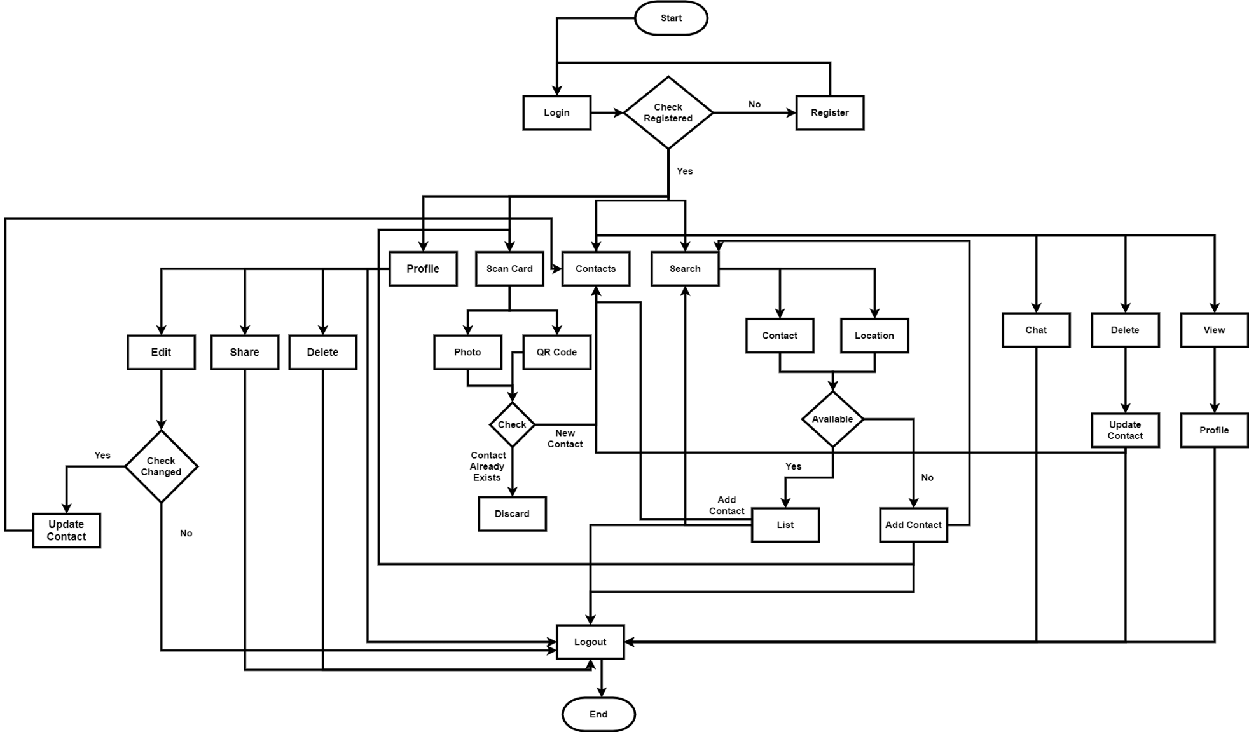

**­**

**Figure 1**

**Goals and Objectives:**

In this app we are providing the following services:

* User can easily create a profile in this application and can save different cards in their profiles which are shared by the different community.
* Businessmen can upload their digital card and share it with the customers.
* Using **QR** code we easily get profile of the person.
* Cards can be shared through email.
* User can hire the professional to get the online services.
* A community chat is available in which a person can take help from other experienced people in the respective community.
* A social circle will be defined using QR code.
* The phone numbers can be picked from the scanned image of the card and then can be saved in the phone directory.
* Suggest the cards of business which is running on the nearby vicinity so that two professionals can exchange it.
* User can scan three different cards simultaneously (if needed) and their data will be saved individually

**Individual Tasks:**

**Table 2**

|  |  |  |
| --- | --- | --- |
| Sr. No | Milestone | Group members |
| 1 | Requirements elicitation  And analysis | Syed Natiq Hussain Shah  Yasir Iqbal |
| 2 | System Design | Syed Natiq Hussain Shah  Yasir Iqbal |
| 3 | Frontend Designing | Syed Natiq Hussain Shah  Yasir Iqbal |
| 4 | Database designing | Syed Natiq Hussain Shah  Yasir Iqbal |
| 5 | System implementation | Syed Natiq Hussain Shah  Yasir Iqbal |
| 6 | Testing | Syed Natiq Hussain Shah  Yasir Iqbal |

**Gantt chart:**

**Table 3**

|  |  |  |
| --- | --- | --- |
| Sr. No | Milestone | Time Duration |
| 1 | Requirements elicitation  And analysis | Sep15, 2020 to Nov 15, 2020  (8 weeks) |
| 2 | System Design | Nov 16, 2020 to Jan 31, 2021  (10 weeks) |
| 3 | Frontend Designing | Feb01, 2021to April 18, 2021  (10 weeks) |
| 4 | Database designing | April 19, 2021to June 20, 2021  (8 weeks) |
| 5 | System implementation | June 21, 2021 to Oct 03, 2021  (14 weeks) |
| 6 | Testing | Oct04, 2021 to Dec05, 2021  (8 weeks) |

**Figure 2**

**Future Work:**

This application can be extended by the developer in future.

* The new functionality of designing the card within the application using drag and drop approach of tools can be added.
* User can easily create the design of the card automatically by scanning the physical print of that business card.
* The user can track the agents of the respective business in their nearby location.

**Tools and Technologies:**

**Table 4**

|  |  |  |  |
| --- | --- | --- | --- |
| **Tools**  **And**  **Technologies** | **Tools** | **Version** | **Rationale** |
| MS Word | 2016 | Documentation |
| Power Point | 2016 | Presentation |
| Android studio | 4.0.1 | Android development |
| PyCharm |  | Python |
| **Technology** | **Version** | **Rationale** |
| Java | **5** | Programming Language |
| Flask |  | Python Framework |
| Firebase |  | Database |
| XML |  | Android Designing |
| Python |  | Programming Language |